Course: ENCS304 – Computer Networks
Name: Nishant Kumar
Roll Number: 2301730068
Program: B.Tech CSE (AI & ML)

Task 2: Bus-like Topology (Hub-Based)
Configuration:
• Switch replaced with Hub
• Same IP addressing scheme used
Testing:
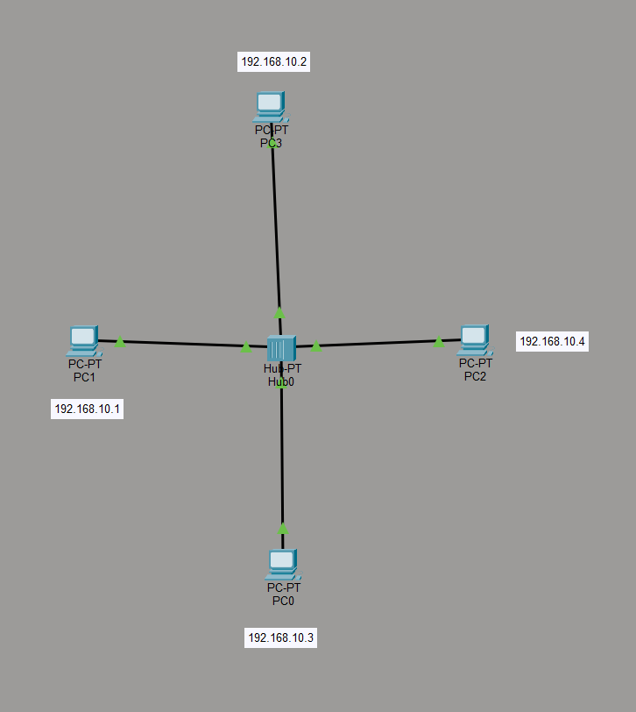
• Simultaneous ping from multiple PCs

Result:
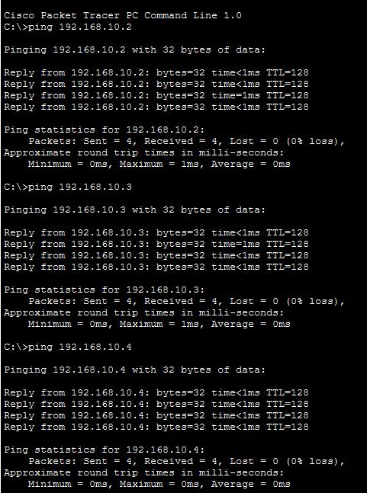

• Pings successful
Observations:
• Hub broadcasts packets to all ports
• More congestion observed in simulation mode
• Less efficient compared to switch

